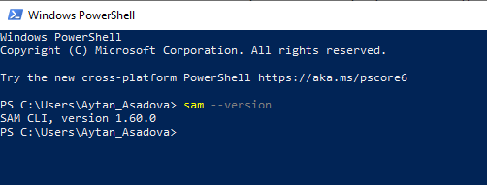

sam build --template-file samTemplate.yml

sam deploy --s3-bucket pinqi-bucket --stack-name lambda-stack --profile admin

CIcd

|  |
| --- |
| version: 0.2  phases:  install:  runtime-versions:  java: corretto11  pre_build:  commands:  - echo Nothing to do in the pre_build phase...  build:  commands:  - echo Build started on `date`  - sam build --template-file samTemplate.yml  post_build:  commands:  - echo Build completed on `date`  - sam package --s3-bucket pinqi-bucket --output-template-file output-lambda-temp.yml artifacts:  files:  - output-lambda-temp.yml |

By default when you use this command, the AWS SAM CLI assumes that your current working directory is your project's root directory. The AWS SAM CLI first tries to locate a template file built using the [sam build](https://docs.aws.amazon.com/serverless-application-model/latest/developerguide/sam-cli-command-reference-sam-build.html) command, located in the .aws-sam subfolder, and named template.yaml. Next, the AWS SAM CLI tries to locate a template file named template.yaml or template.yml in the current working directory. If you specify the --template option, AWS SAM CLI's default behavior is overridden, and will package just that AWS SAM template and the local resources it points to.

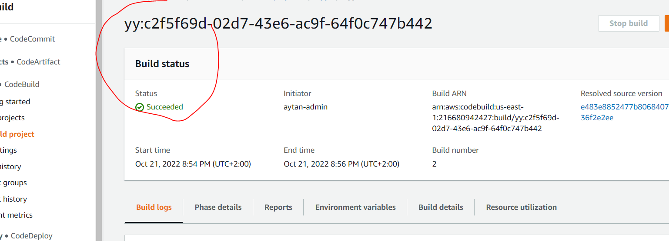

Codedeploy cloudformation roles

